import numpy as np
import pandas as pd
import matplotlib.pyplot as plt
from sklearn.model_selection import train_test_split
data=pd.read_csv("D:\DESKTOP\Pattern recognition\Logistic_Regresion_on_diabetesDataset\diabetes.csv")
data.head()
<>:1: SyntaxWarning: invalid escape sequence '\D'
<>:1: SyntaxWarning: invalid escape sequence '\D'
C:\Users\wajid\AppData\Local\Temp\ipykernel_28156\801103447.py:1: SyntaxWarning: invalid escape sequence '\D'
data=pd.read_csv("D:\DESKTOP\Pattern recognition\Logistic_Regresion_on_diabetesDataset\diabetes.csv")
Pregnancies Glucose BloodPressure SkinThickness Insulin BMI \
0 6 148 72 35 0 33.6
1 1 85 66 29 0 26.6
2 8 183 64 0 0 23.3
3 1 89 66 23 94 28.1
4 0 137 40 35 168 43.1
DiabetesPedigreeFunction Age Outcome
0 0.627 50 1
1 0.351 31 0
2 0.672 32 1
3 0.167 21 0
4 2.288 33 1
data.isna().sum()
Pregnancies 0
Glucose 0
BloodPressure 0
SkinThickness 0
Insulin 0
BMI 0
DiabetesPedigreeFunction 0
Age 0
Outcome 0
dtype: int64
normalized_dataset = (data - data.min()) / (data.max() - data.min())
# Split dataset into features and target
X = normalized_dataset.drop('Outcome', axis=1).values
y = normalized_dataset['Outcome'].values.reshape(-1, 1)
def train_val_test_split(X, y, train_ratio, val_ratio, test_ratio, random_state=42):
assert train_ratio + val_ratio + test_ratio == 1, "Ratios should sum up to 1"
X_train_val, X_test, y_train_val, y_test = train_test_split(X, y, test_size=test_ratio, random_state=random_state)
remaining_ratio = 1 - test_ratio
train_val_ratio = train_ratio / remaining_ratio
X_train, X_val, y_train, y_val = train_test_split(X_train_val, y_train_val, test_size=(val_ratio / remaining_ratio), random_state=random_state)
return X_train, X_val, X_test, y_train, y_val, y_test
train_ratio = 0.7
val_ratio = 0.2
test_ratio = 1-train_ratio-val_ratio
X_train, X_val, X_test, y_train, y_val, y_test = train_val_test_split(X, y, train_ratio=0.7, val_ratio=0.2, test_ratio=1-train_ratio-val_ratio)
print("Train size:", X_train.shape[0])
print("Validation size:", X_val.shape[0])
print("Test size:", X_test.shape[0])
Train size: 537
Validation size: 154
Test size: 77
class LogisticRegression:
def __init__(self, learning_rate=0.01, num_iterations=1000, gradient_descent='batch'):
self.learning_rate = learning_rate
self.num_iterations = num_iterations
self.theta = None
self.cost_history_train = []
self.cost_history_val = []
self.gradient_descent = gradient_descent
def sigmoid(self, z):
return 1 / (1 + np.exp(-z))
def fit(self, X, y, X_val, y_val):
# Initialize parameters
m, n = X.shape
self.theta = np.zeros((n, 1))
# Gradient Descent
for i in range(self.num_iterations):
if self.gradient_descent == 'batch':
# Batch Gradient Descent
z = np.dot(X, self.theta)
h = self.sigmoid(z)
gradient = np.dot(X.T, (h - y)) / m
self.theta -= self.learning_rate * gradient
elif self.gradient_descent == 'stochastic':
# Stochastic Gradient Descent
for j in range(m):
rand_index = np.random.randint(0, m)
X_single = X[rand_index, :].reshape(1, -1)
y_single = y[rand_index].reshape(1, -1)
z = np.dot(X_single, self.theta)
h = self.sigmoid(z)
gradient = np.dot(X_single.T, (h - y_single))
self.theta -= self.learning_rate * gradient
# Compute and store cost for training set
cost_train = self.compute_cost(X, y)
self.cost_history_train.append(cost_train)
# Compute and store cost for validation set
cost_val = self.compute_cost(X_val, y_val)
self.cost_history_val.append(cost_val)
def compute_cost(self, X, y):
m = len(y)
z = np.dot(X, self.theta)
h = self.sigmoid(z)
epsilon = 1e-5 # to avoid log(0) which is undefined
cost = (-1 / m) * np.sum(y * np.log(h + epsilon) + (1 - y) * np.log(1 - h + epsilon))
return cost
def predict(self, X, threshold=0.5):
z = np.dot(X, self.theta)
probabilities = self.sigmoid(z)
predictions = (probabilities >= threshold).astype(int)
return predictions
# Train the model using Batch Gradient Descent
log_reg_batch = LogisticRegression(learning_rate=0.01, num_iterations=1000, gradient_descent='batch')
log_reg_batch.fit(X_train, y_train, X_val, y_val)
print("BGD completed")
# Train the model using Stochastic Gradient Descent
log_reg_stochastic = LogisticRegression(learning_rate=0.01, num_iterations=1000, gradient_descent='stochastic')
log_reg_stochastic.fit(X_train, y_train, X_val, y_val)
print("SGD completed")
BGD completed
SGD completed
plt.plot(range(log_reg_batch.num_iterations), log_reg_batch.cost_history_train, label='Batch GD', color='blue')
plt.plot(range(log_reg_stochastic.num_iterations), log_reg_stochastic.cost_history_train, label='Stochastic GD', color='red')
plt.xlabel('Iterations')
plt.ylabel('Loss')
plt.title('Training Loss vs. Iterations')
plt.legend()
plt.show()
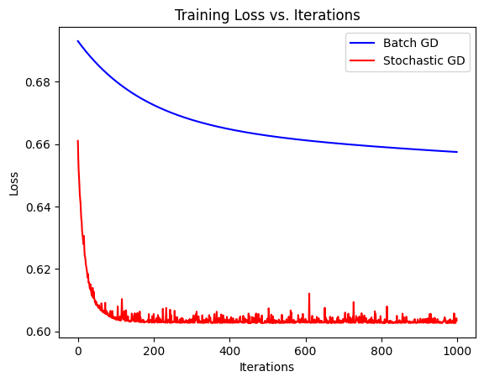
plt.plot(range(log_reg_batch.num_iterations), log_reg_batch.cost_history_val, label='Batch GD', color='blue')
plt.plot(range(log_reg_stochastic.num_iterations), log_reg_stochastic.cost_history_val, label='Stochastic GD', color='red')
plt.xlabel('Iterations')
plt.ylabel('Loss')
plt.title('Validation Loss vs. Iterations')
plt.legend()
plt.show()
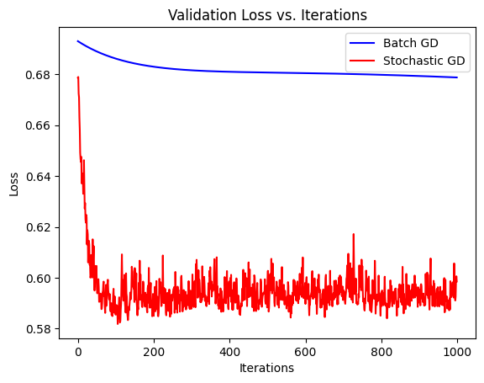
# Re-Running on different learning rates
learning_rates = [0.01, 0.0001, 10]
# Initialize lists to store trained models
log_reg_models = []
# Train models for different learning rates
for lr in learning_rates:
log_reg = LogisticRegression(learning_rate=lr, num_iterations=1000)
log_reg.fit(X_train, y_train, X_val, y_val)
log_reg_models.append(log_reg)
# Plot training loss vs. iterations for each learning rate
plt.figure(figsize=(14, 8))
for i, lr in enumerate(learning_rates):
if lr == 10:
plt.plot(range(log_reg_models[i].num_iterations), log_reg_models[i].cost_history_train, label=f'LR={lr}', alpha=0.5)
else:
plt.plot(range(log_reg_models[i].num_iterations), log_reg_models[i].cost_history_train, label=f'LR={lr}')
plt.xlabel('Iterations')
plt.ylabel('Training Loss')
plt.title('Training Loss vs. Iterations for Different Learning Rates')
plt.legend()
plt.show()
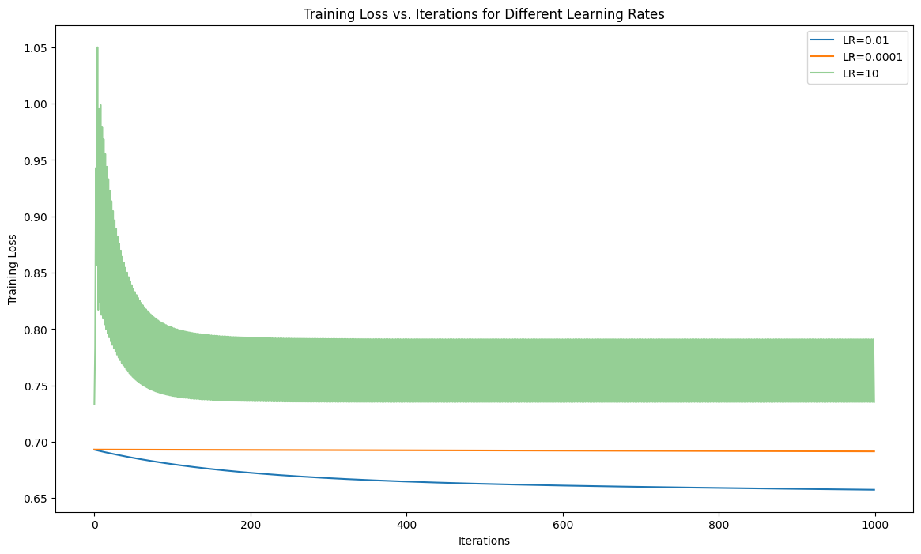
# Plot validation loss vs. iterations for each learning rate
plt.figure(figsize=(14, 8))
for i, lr in enumerate(learning_rates):
if lr == 10:
plt.plot(range(log_reg_models[i].num_iterations), log_reg_models[i].cost_history_val, label=f'LR={lr}', alpha=0.5)
else:
plt.plot(range(log_reg_models[i].num_iterations), log_reg_models[i].cost_history_val, label=f'LR={lr}')
plt.xlabel('Iterations')
plt.ylabel('Validation Loss')
plt.title('Validation Loss vs. Iterations for Different Learning Rates')
plt.legend()
plt.show()
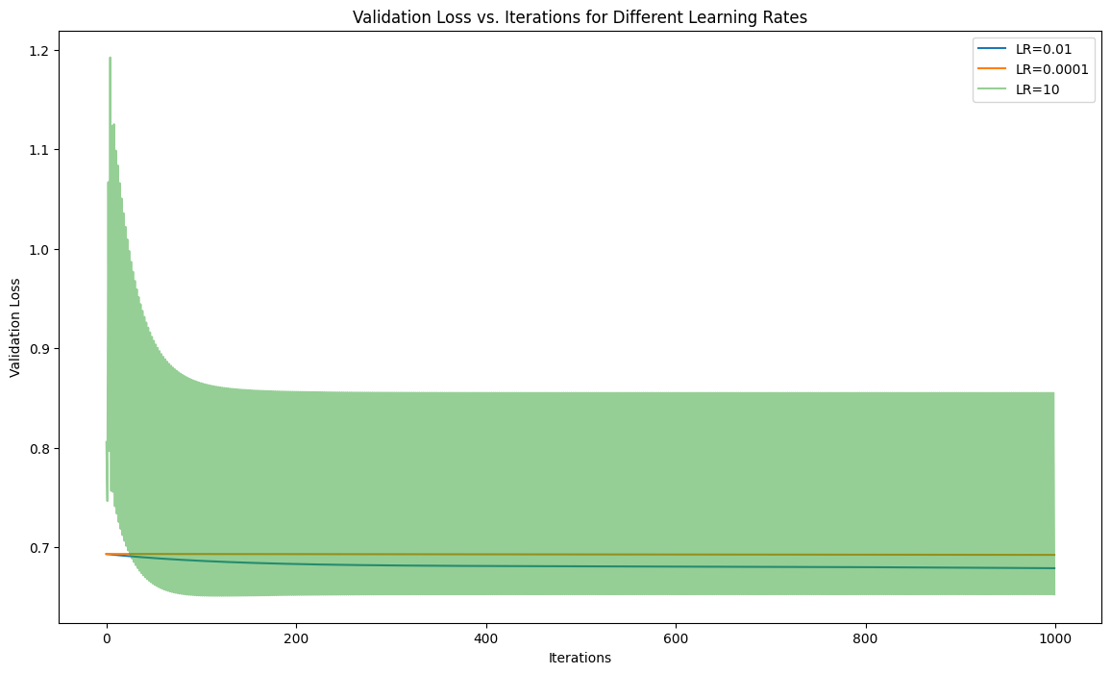
class MetricsCalculator:
@staticmethod
def confusion_matrix(actual, predicted):
tp = 0
fp = 0
tn = 0
fn = 0
for i in range(len(actual)):
if actual[i] == 1 and predicted[i] == 1:
tp += 1
elif actual[i] == 0 and predicted[i] == 1:
fp += 1
elif actual[i] == 0 and predicted[i] == 0:
tn += 1
elif actual[i] == 1 and predicted[i] == 0:
fn += 1
return tp, fp, tn, fn
@staticmethod
def accuracy(tp, fp, tn, fn):
total = tp + fp + tn + fn
correct = tp + tn
return correct / total
@staticmethod
def precision(tp, fp):
return tp / (tp + fp) if tp + fp != 0 else 0
@staticmethod
def recall(tp, fn):
return tp / (tp + fn) if tp + fn != 0 else 0
@staticmethod
def f1_score(precision, recall):
return 2 * (precision * recall) / (precision + recall) if precision + recall != 0 else 0
y_pred_test = log_reg.predict(X_test)
# Calculate confusion matrix
tp, fp, tn, fn = MetricsCalculator.confusion_matrix(y_test.flatten(), y_pred_test.flatten())
accuracy = MetricsCalculator.accuracy(tp, fp, tn, fn)
precision = MetricsCalculator.precision(tp, fp)
recall = MetricsCalculator.recall(tp, fn)
f1_score = MetricsCalculator.f1_score(precision, recall)
print("Confusion Matrix:")
print("True Positive:", tp)
print("False Positive:", fp)
print("True Negative:", tn)
print("False Negative:", fn)
print("\nAccuracy:", accuracy)
print("Precision:", precision)
print("Recall:", recall)
print("F1 Score:", f1_score)
Confusion Matrix:
True Positive: 22
False Positive: 30
True Negative: 20
False Negative: 5
Accuracy: 0.5454545454545454
Precision: 0.4230769230769231
Recall: 0.8148148148148148
F1 Score: 0.5569620253164557
def calculate_probabilities(X, theta):
z = np.dot(X, theta)
probabilities = 1 / (1 + np.exp(-z))
return probabilities
y_probabilities = calculate_probabilities(X_test, log_reg.theta)
# Define a function to make predictions based on a threshold
def predict_with_threshold(probabilities, threshold):
return (probabilities >= threshold).astype(int)
# Define thresholds to evaluate
thresholds = [0.3, 0.4, 0.5, 0.6, 0.7]
# Calculate metrics for each threshold
metrics_for_thresholds = {}
for threshold in thresholds:
y_pred = predict_with_threshold(y_probabilities, threshold)
tp, fp, tn, fn = MetricsCalculator.confusion_matrix(y_test.flatten(), y_pred.flatten())
precision = MetricsCalculator.precision(tp, fp)
recall = MetricsCalculator.recall(tp, fn)
f1_score = MetricsCalculator.f1_score(precision, recall)
metrics_for_thresholds[threshold] = {'Precision': precision, 'Recall': recall, 'F1 Score': f1_score}
print("Metrics for Different Thresholds:")
for threshold, metrics in metrics_for_thresholds.items():
print(f"Threshold: {threshold}")
print(f"Precision: {metrics['Precision']}")
print(f"Recall: {metrics['Recall']}")
print(f"F1 Score: {metrics['F1 Score']}")
print()
Metrics for Different Thresholds:
Threshold: 0.3
Precision: 0.3424657534246575
Recall: 0.9259259259259259
F1 Score: 0.5
Threshold: 0.4
Precision: 0.39344262295081966
Recall: 0.8888888888888888
F1 Score: 0.5454545454545455
Threshold: 0.5
Precision: 0.4230769230769231
Recall: 0.8148148148148148
F1 Score: 0.5569620253164557
Threshold: 0.6
Precision: 0.4782608695652174
Recall: 0.8148148148148148
F1 Score: 0.6027397260273973
Threshold: 0.7
Precision: 0.4864864864864865
Recall: 0.6666666666666666
F1 Score: 0.5625
def calculate_accuracy(y_true, y_pred):
correct = np.sum(y_true == y_pred)
total = len(y_true)
accuracy = correct / total
return accuracy
accuracies_for_thresholds = {}
for threshold in thresholds:
y_pred = predict_with_threshold(y_probabilities, threshold)
accuracy = calculate_accuracy(y_test.flatten(), y_pred.flatten())
accuracies_for_thresholds[threshold] = accuracy
# Print accuracy for each threshold
print("Accuracy for Different Thresholds:")
for threshold, accuracy in accuracies_for_thresholds.items():
print(f"Threshold: {threshold}, Accuracy: {accuracy}")
Accuracy for Different Thresholds:
Threshold: 0.3, Accuracy: 0.35064935064935066
Threshold: 0.4, Accuracy: 0.4805194805194805
Threshold: 0.5, Accuracy: 0.5454545454545454
Threshold: 0.6, Accuracy: 0.6233766233766234
Threshold: 0.7, Accuracy: 0.6363636363636364
#Sklearn Logistic regression
from sklearn.model_selection import GridSearchCV
from sklearn.linear_model import LogisticRegression as SklearnLogisticRegression
param_grid = {
'C': [0.01, 0.1, 1, 10, 100], # Inverse regularization strength (smaller values specify stronger regularization)
'max_iter': [1000] # Maximum number of iterations for optimization
}
# Create Logistic Regression model
sklearn_log_reg = SklearnLogisticRegression()
# Perform grid search with cross-validation
grid_search = GridSearchCV(sklearn_log_reg, param_grid, cv=5, scoring='accuracy')
grid_search.fit(X_train, y_train)
c:\Users\wajid\AppData\Local\Programs\Python\Python312\Lib\site-packages\sklearn\utils\validation.py:1229: DataConversionWarning: A column-vector y was passed when a 1d array was expected. Please change the shape of y to (n_samples, ), for example using ravel().
y = column_or_1d(y, warn=True)
c:\Users\wajid\AppData\Local\Programs\Python\Python312\Lib\site-packages\sklearn\utils\validation.py:1229: DataConversionWarning: A column-vector y was passed when a 1d array was expected. Please change the shape of y to (n_samples, ), for example using ravel().
y = column_or_1d(y, warn=True)
c:\Users\wajid\AppData\Local\Programs\Python\Python312\Lib\site-packages\sklearn\utils\validation.py:1229: DataConversionWarning: A column-vector y was passed when a 1d array was expected. Please change the shape of y to (n_samples, ), for example using ravel().
y = column_or_1d(y, warn=True)
c:\Users\wajid\AppData\Local\Programs\Python\Python312\Lib\site-packages\sklearn\utils\validation.py:1229: DataConversionWarning: A column-vector y was passed when a 1d array was expected. Please change the shape of y to (n_samples, ), for example using ravel().
y = column_or_1d(y, warn=True)
c:\Users\wajid\AppData\Local\Programs\Python\Python312\Lib\site-packages\sklearn\utils\validation.py:1229: DataConversionWarning: A column-vector y was passed when a 1d array was expected. Please change the shape of y to (n_samples, ), for example using ravel().
y = column_or_1d(y, warn=True)
c:\Users\wajid\AppData\Local\Programs\Python\Python312\Lib\site-packages\sklearn\utils\validation.py:1229: DataConversionWarning: A column-vector y was passed when a 1d array was expected. Please change the shape of y to (n_samples, ), for example using ravel().
y = column_or_1d(y, warn=True)
c:\Users\wajid\AppData\Local\Programs\Python\Python312\Lib\site-packages\sklearn\utils\validation.py:1229: DataConversionWarning: A column-vector y was passed when a 1d array was expected. Please change the shape of y to (n_samples, ), for example using ravel().
y = column_or_1d(y, warn=True)
c:\Users\wajid\AppData\Local\Programs\Python\Python312\Lib\site-packages\sklearn\utils\validation.py:1229: DataConversionWarning: A column-vector y was passed when a 1d array was expected. Please change the shape of y to (n_samples, ), for example using ravel().
y = column_or_1d(y, warn=True)
c:\Users\wajid\AppData\Local\Programs\Python\Python312\Lib\site-packages\sklearn\utils\validation.py:1229: DataConversionWarning: A column-vector y was passed when a 1d array was expected. Please change the shape of y to (n_samples, ), for example using ravel().
y = column_or_1d(y, warn=True)
c:\Users\wajid\AppData\Local\Programs\Python\Python312\Lib\site-packages\sklearn\utils\validation.py:1229: DataConversionWarning: A column-vector y was passed when a 1d array was expected. Please change the shape of y to (n_samples, ), for example using ravel().
y = column_or_1d(y, warn=True)
c:\Users\wajid\AppData\Local\Programs\Python\Python312\Lib\site-packages\sklearn\utils\validation.py:1229: DataConversionWarning: A column-vector y was passed when a 1d array was expected. Please change the shape of y to (n_samples, ), for example using ravel().
y = column_or_1d(y, warn=True)
c:\Users\wajid\AppData\Local\Programs\Python\Python312\Lib\site-packages\sklearn\utils\validation.py:1229: DataConversionWarning: A column-vector y was passed when a 1d array was expected. Please change the shape of y to (n_samples, ), for example using ravel().
y = column_or_1d(y, warn=True)
c:\Users\wajid\AppData\Local\Programs\Python\Python312\Lib\site-packages\sklearn\utils\validation.py:1229: DataConversionWarning: A column-vector y was passed when a 1d array was expected. Please change the shape of y to (n_samples, ), for example using ravel().
y = column_or_1d(y, warn=True)
c:\Users\wajid\AppData\Local\Programs\Python\Python312\Lib\site-packages\sklearn\utils\validation.py:1229: DataConversionWarning: A column-vector y was passed when a 1d array was expected. Please change the shape of y to (n_samples, ), for example using ravel().
y = column_or_1d(y, warn=True)
c:\Users\wajid\AppData\Local\Programs\Python\Python312\Lib\site-packages\sklearn\utils\validation.py:1229: DataConversionWarning: A column-vector y was passed when a 1d array was expected. Please change the shape of y to (n_samples, ), for example using ravel().
y = column_or_1d(y, warn=True)
c:\Users\wajid\AppData\Local\Programs\Python\Python312\Lib\site-packages\sklearn\utils\validation.py:1229: DataConversionWarning: A column-vector y was passed when a 1d array was expected. Please change the shape of y to (n_samples, ), for example using ravel().
y = column_or_1d(y, warn=True)
c:\Users\wajid\AppData\Local\Programs\Python\Python312\Lib\site-packages\sklearn\utils\validation.py:1229: DataConversionWarning: A column-vector y was passed when a 1d array was expected. Please change the shape of y to (n_samples, ), for example using ravel().
y = column_or_1d(y, warn=True)
c:\Users\wajid\AppData\Local\Programs\Python\Python312\Lib\site-packages\sklearn\utils\validation.py:1229: DataConversionWarning: A column-vector y was passed when a 1d array was expected. Please change the shape of y to (n_samples, ), for example using ravel().
y = column_or_1d(y, warn=True)
c:\Users\wajid\AppData\Local\Programs\Python\Python312\Lib\site-packages\sklearn\utils\validation.py:1229: DataConversionWarning: A column-vector y was passed when a 1d array was expected. Please change the shape of y to (n_samples, ), for example using ravel().
y = column_or_1d(y, warn=True)
c:\Users\wajid\AppData\Local\Programs\Python\Python312\Lib\site-packages\sklearn\utils\validation.py:1229: DataConversionWarning: A column-vector y was passed when a 1d array was expected. Please change the shape of y to (n_samples, ), for example using ravel().
y = column_or_1d(y, warn=True)
c:\Users\wajid\AppData\Local\Programs\Python\Python312\Lib\site-packages\sklearn\utils\validation.py:1229: DataConversionWarning: A column-vector y was passed when a 1d array was expected. Please change the shape of y to (n_samples, ), for example using ravel().
y = column_or_1d(y, warn=True)
c:\Users\wajid\AppData\Local\Programs\Python\Python312\Lib\site-packages\sklearn\utils\validation.py:1229: DataConversionWarning: A column-vector y was passed when a 1d array was expected. Please change the shape of y to (n_samples, ), for example using ravel().
y = column_or_1d(y, warn=True)
c:\Users\wajid\AppData\Local\Programs\Python\Python312\Lib\site-packages\sklearn\utils\validation.py:1229: DataConversionWarning: A column-vector y was passed when a 1d array was expected. Please change the shape of y to (n_samples, ), for example using ravel().
y = column_or_1d(y, warn=True)
c:\Users\wajid\AppData\Local\Programs\Python\Python312\Lib\site-packages\sklearn\utils\validation.py:1229: DataConversionWarning: A column-vector y was passed when a 1d array was expected. Please change the shape of y to (n_samples, ), for example using ravel().
y = column_or_1d(y, warn=True)
c:\Users\wajid\AppData\Local\Programs\Python\Python312\Lib\site-packages\sklearn\utils\validation.py:1229: DataConversionWarning: A column-vector y was passed when a 1d array was expected. Please change the shape of y to (n_samples, ), for example using ravel().
y = column_or_1d(y, warn=True)
c:\Users\wajid\AppData\Local\Programs\Python\Python312\Lib\site-packages\sklearn\utils\validation.py:1229: DataConversionWarning: A column-vector y was passed when a 1d array was expected. Please change the shape of y to (n_samples, ), for example using ravel().
y = column_or_1d(y, warn=True)
GridSearchCV(cv=5, estimator=LogisticRegression(),
param_grid={'C': [0.01, 0.1, 1, 10, 100], 'max_iter': [1000]},
scoring='accuracy')
print("Best Parameters:", grid_search.best_params_)
# Use the best parameters to train the model
best_lr = grid_search.best_params_['C']
best_epochs = grid_search.best_params_['max_iter']
sklearn_log_reg_best = SklearnLogisticRegression(C=best_lr, max_iter=best_epochs)
sklearn_log_reg_best.fit(X_train, y_train)
Best Parameters: {'C': 100, 'max_iter': 1000}
c:\Users\wajid\AppData\Local\Programs\Python\Python312\Lib\site-packages\sklearn\utils\validation.py:1229: DataConversionWarning: A column-vector y was passed when a 1d array was expected. Please change the shape of y to (n_samples, ), for example using ravel().
y = column_or_1d(y, warn=True)
LogisticRegression(C=100, max_iter=1000)
y_probabilities_sklearn = sklearn_log_reg_best.predict_proba(X_test)[:, 1]
# Calculate metrics for Sklearn's implementation
y_pred_sklearn = sklearn_log_reg_best.predict(X_test)
tp_sklearn, fp_sklearn, tn_sklearn, fn_sklearn = MetricsCalculator.confusion_matrix(y_test.flatten(), y_pred_sklearn.flatten())
accuracy_sklearn = MetricsCalculator.accuracy(tp_sklearn, fp_sklearn, tn_sklearn, fn_sklearn)
precision_sklearn = MetricsCalculator.precision(tp_sklearn, fp_sklearn)
recall_sklearn = MetricsCalculator.recall(tp_sklearn, fn_sklearn)
f1_score_sklearn = MetricsCalculator.f1_score(precision_sklearn, recall_sklearn)
# Print metrics for Sklearn's implementation
print("Metrics for Sklearn's Implementation:")
print("Accuracy:", accuracy_sklearn)
print("Precision:", precision_sklearn)
print("Recall:", recall_sklearn)
print("F1 Score:", f1_score_sklearn)
Metrics for Sklearn's Implementation:
Accuracy: 0.7012987012987013
Precision: 0.5666666666666667
Recall: 0.6296296296296297
F1 Score: 0.5964912280701755
log_reg.fit(X_train, y_train, X_val, y_val)
loss_history_custom_train = log_reg.cost_history_train
loss_history_custom_val = log_reg.cost_history_val
plt.figure(figsize=(12, 6))
plt.plot(range(len(loss_history_custom_train)), loss_history_custom_train, label='My Implementation (Train)', color='blue')
plt.plot(range(len(loss_history_custom_val)), loss_history_custom_val, label='My Implementation (Validation)', color='lightgreen', alpha=0.5)
plt.xlabel('Iterations')
plt.ylabel('Loss')
plt.title('Loss History')
plt.legend()
plt.show()
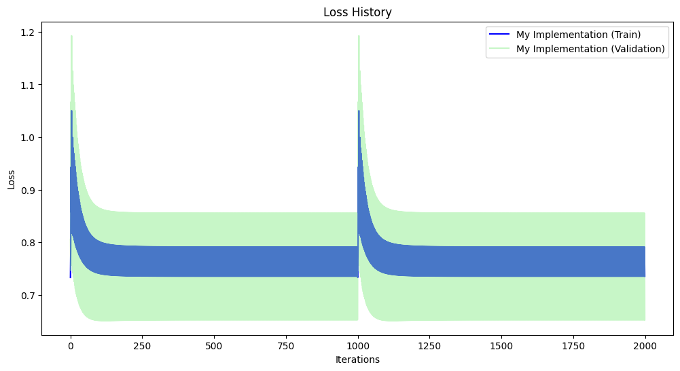
sklearn_log_reg_best.fit(X_train, y_train)
# Calculate the negative log-likelihood values for each iteration
neg_log_likelihood = -sklearn_log_reg_best.decision_function(X_train)
# Plot the negative log-likelihood over iterations
plt.figure(figsize=(12, 6))
plt.plot(np.arange(1, len(neg_log_likelihood) + 1), neg_log_likelihood, label='Sklearn Implementation (Train)', color='red')
plt.xlabel('Iterations')
plt.ylabel('Negative Log-Likelihood')
plt.title('Convergence Behavior of Sklearn Implementation')
plt.legend()
plt.show()
c:\Users\wajid\AppData\Local\Programs\Python\Python312\Lib\site-packages\sklearn\utils\validation.py:1229: DataConversionWarning: A column-vector y was passed when a 1d array was expected. Please change the shape of y to (n_samples, ), for example using ravel().
y = column_or_1d(y, warn=True)
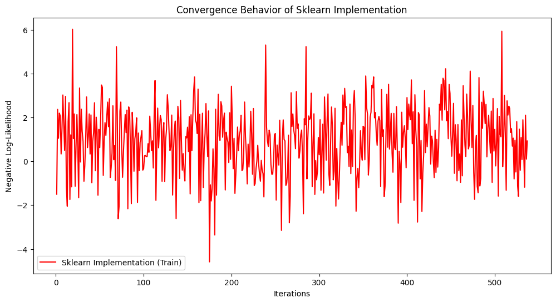
y_pred_custom_train = log_reg.predict(X_train)
y_pred_custom_test = log_reg.predict(X_test)
tp_custom_train, fp_custom_train, tn_custom_train, fn_custom_train = MetricsCalculator.confusion_matrix(y_train.flatten(), y_pred_custom_train.flatten())
tp_custom_test, fp_custom_test, tn_custom_test, fn_custom_test = MetricsCalculator.confusion_matrix(y_test.flatten(), y_pred_custom_test.flatten())
accuracy_custom_train = MetricsCalculator.accuracy(tp_custom_train, fp_custom_train, tn_custom_train, fn_custom_train)
precision_custom_train = MetricsCalculator.precision(tp_custom_train, fp_custom_train)
recall_custom_train = MetricsCalculator.recall(tp_custom_train, fn_custom_train)
f1_score_custom_train = MetricsCalculator.f1_score(precision_custom_train, recall_custom_train)
accuracy_custom_test = MetricsCalculator.accuracy(tp_custom_test, fp_custom_test, tn_custom_test, fn_custom_test)
precision_custom_test = MetricsCalculator.precision(tp_custom_test, fp_custom_test)
recall_custom_test = MetricsCalculator.recall(tp_custom_test, fn_custom_test)
f1_score_custom_test = MetricsCalculator.f1_score(precision_custom_test, recall_custom_test)
print("Performance Metrics for MY Implementation:")
print("Train Accuracy:", accuracy_custom_train)
print("Train Precision:", precision_custom_train)
print("Train Recall:", recall_custom_train)
print("Train F1 Score:", f1_score_custom_train)
print()
print("Test Accuracy:", accuracy_custom_test)
print("Test Precision:", precision_custom_test)
print("Test Recall:", recall_custom_test)
print("Test F1 Score:", f1_score_custom_test)
print()
# Print metrics for Sklearn's implementation
print("Performance Metrics for Sklearn's Implementation:")
print("Accuracy:", accuracy_sklearn)
print("Precision:", precision_sklearn)
print("Recall:", recall_sklearn)
print("F1 Score:", f1_score_sklearn)
Performance Metrics for MY Implementation:
Train Accuracy: 0.62756052141527
Train Precision: 0.47337278106508873
Train Recall: 0.8791208791208791
Train F1 Score: 0.6153846153846153
Test Accuracy: 0.5454545454545454
Test Precision: 0.4230769230769231
Test Recall: 0.8148148148148148
Test F1 Score: 0.5569620253164557
Performance Metrics for Sklearn's Implementation:
Accuracy: 0.7012987012987013
Precision: 0.5666666666666667
Recall: 0.6296296296296297
F1 Score: 0.5964912280701755

